**Write a C program to find Factorial of a given number using Recursion**

**INPUT:**

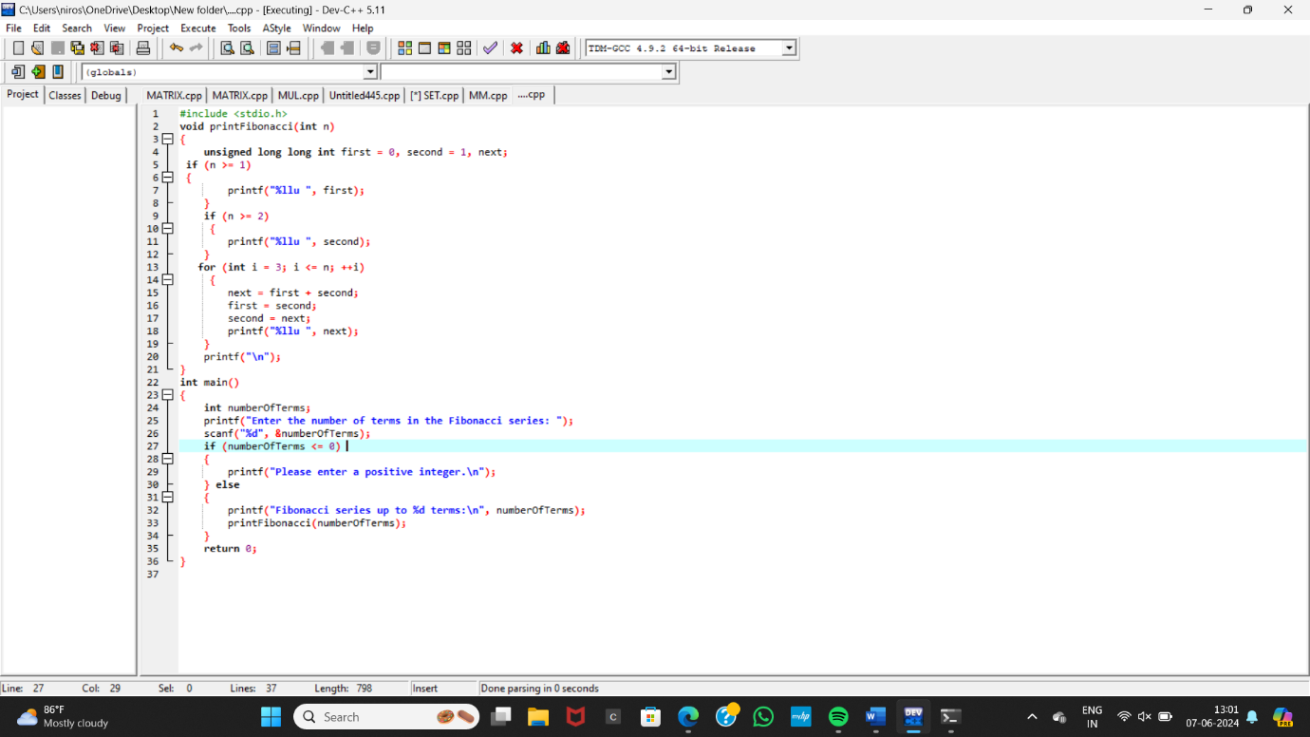

**OUTPUT:**

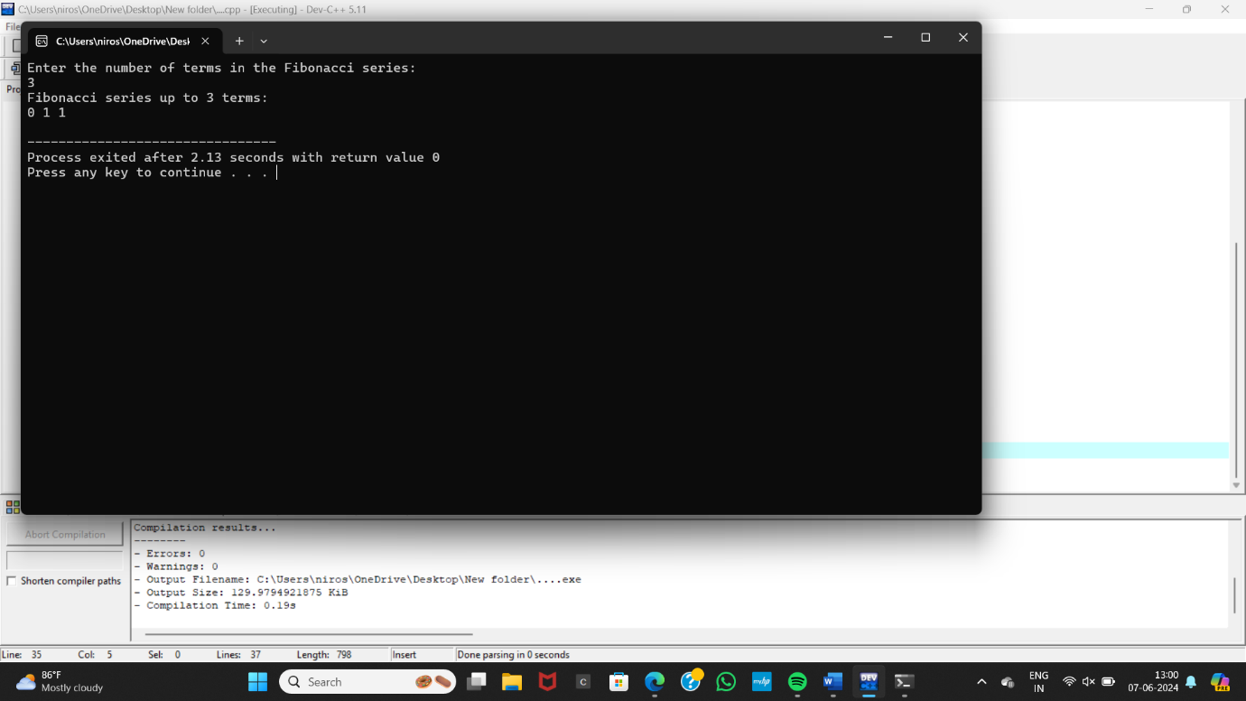S